Is AVID Right For You?
Do you want to go to college? Are any of the following true about you?
- You plan to attend college after high school.
- You will be the first in your family to go to college.
- You do well on tests but have trouble staying organized.
- You want to be a leader on campus.
- Your ethnicity is underrepresented on college campuses.
- You really want to do well in school and are willing to work hard and do whatever it takes to reach your goals.
- You want to work in a collaborative environment with people who will be on a team with you throughout high school.
What can I expect in the AVID program?
AVID is about INDIVIDUAL determination and hard work amongst a group of like-minded students, tutors and teachers to help support high school students to their INDIVIDUAL success on the path to college and career.

9th *Foundational year:  - Transition to high school strategies  - Instruction, support and accountability in:  - note-taking  - organization  - grade monitoring and goal setting  - college and career exploration and research  - Tutorials with tutors in class up to two times a week  - Weekly Grade Checks and chats with AVID Teacher  - Academic success and focus in writing, reading, inquiry and collaboration  - Oral Presentation and Self-Confidence Building  - Team Building Activities  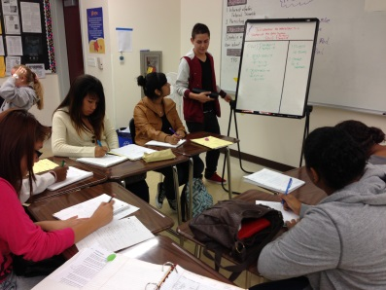  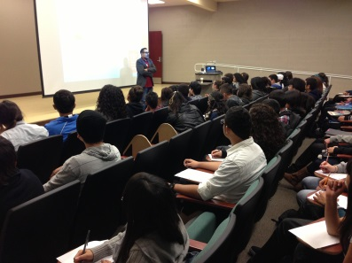  - Guest Speakers | 10th  All of the key foundational elements that were implemented in 9th grade continue and 10th grade builds with:  - PSAT (Practice SAT) Practice and Support  - RoadTrip Nation (Personal Interests that lead to careers with videos, interviews and projects)  - Public Speaking  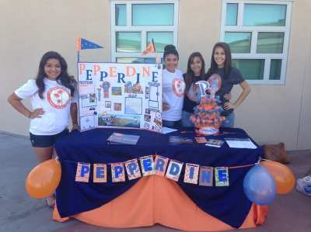  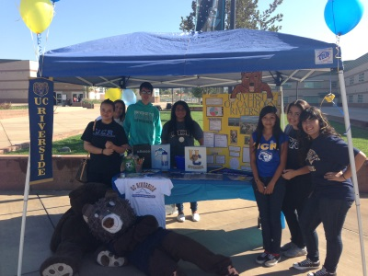  - School-wide Annual AVID College Fair
11th  All of the key foundational elements that were implemented in 9th and 10th grade continue and 11th grade builds with:  - SAT practice and support  - AP skills and support  - CAASP preparation  - Leadership project  - Junior Trip College Tour  - Resume, interview, and personal statement skills and support  - College and career guidance | 12th  All of the key foundational elements that were implemented in 9th – 11th grade continue and 12th grade builds with:  - College Application process guidance  - Financial Aid process guidance  - Research Project  - Senior Stress Management Tips  - Transition to Study Groups  - Transition to College
How do I join AVID? How do I continue in the program?
 | Currently in AVID | Not Currently in AVID
9th grade | - Complete appropriate application  - Recommendation from current AVID teacher  Out of District  - Submit appropriate application  - Recommendation from current AVID teacher  - Transcript  * Submitting application late may result in wait list | - Complete appropriate application  - Attach transcript  - 2.5-3.5 GPA  - Proficient CAASP Scores  Out of District  - Complete appropriate application  - Attach transcript  - 2.5-3.5 GPA  - Proficient CAASP Scores  * Submitting application late may result in wait list
10th Grade & 11th Grade | In order to continue in AVID:  - Have a plan to be A-G compliant  - No attendance or discipline issues  - Should take at least one honors or AP class sophomore year  - Should take at least one AP class junior year | Both within and out of district:  - Complete appropriate application  - 2.5-3.5 GPA  - Have a plan to be A-G compliant  - No attendance or discipline issues  - Attach transcript  - Previous year in AVID for 11th grade entrance  * Submitting application late may result in wait list. Students may also be waitlisted if there is no room in the classes.
12th Grade | In order to continue in AVID:  - Must have completed the Junior Seminar class with a C or better.  - A- G compliant before entering the 12th grade (all summer school, credit recovery, make-up classes, etc.)  - Microsoft/Computer class completed before entering 12th grade (exceptions reviewed)  - Must take at least one AP class senior year.  - No home or TA periods* (exceptions reviewed).  - No attendance or discipline issues  *Consider becoming an AVID student-tutor | Within the district:  - Must be in Junior Seminar to be eligible for Senior Seminar.  Out of district:  - Complete appropriate application and meet same requirements as students within the district.  * Submitting application late may result in wait list. Students may also be waitlisted if there is no room in the classes.
Additional Information for all AVID Students | - Turn in applications before the end of school year to receive notification of acceptance for the next school year.  - If you turn in application in summer/start of school year, you will not receive notice until first week of school.  - A grade of D in AVID, any semester, may result in drop from program pending Faculty Council decision.  - A grade of F in AVID, any semester, will result in being dropped from the program.  - Attendance and discipline issues will be considered by the AVID Site Team.
What are the protocols for exiting the AVID Program?
Faculty Council Probation and Exiting:

If your grades are not all C or higher in all academic class at any given grading period, you will be placed on academic probation, which includes a letter home and mandatory tutoring. If you do not bring the grade up by the next grading period, you may be exited from the program. You must have a plan to be A-G compliant BEFORE you enter your senior year.

Voluntary Exiting:
If you wish to voluntarily exit from the AVID Program, you must fill out a “Request to Drop” AVID Form and it must be approved by your teacher, counselor and parent. *If you request to drop before the school year begins, when you receive your schedule, you are not required to have your teacher sign.

